

Mind in Kingston Empowering Minds Forum Volunteer Role Description
Mind in Kingston is a charity that supports people with a range of mental health issues in the Borough of Kingston upon Thames. We offer services throughout the borough, including Drop-in Cafes, Counselling, Art Therapy, Physical Activity groups, Floating Support and Advice & Information. We are looking for organised, enthusiastic and pro-active people to support the launch and delivery of our new “Empowering Minds Forum”.

What is the Empowering Minds Forum?
The aim of this Empowering Minds Forum (EMF) is to give individuals with experience of statutory and voluntary mental health services a voice and the opportunity to influence future service development. We want to ensure that what we do meets the needs of our beneficiaries, and we want to support our beneficiaries to help improve other mental health services they use.
The EMF will take place anywhere and in any shape to ensure it is accessible and open to all. This will include having physical and online feedback meetings, meeting with beneficiaries in the local community, gathering thoughts through online surveys and using telephone, email and social media as well.

What do we want to do?
- To review Mind in Kingston’s existing services to identify gaps and areas of improvement as well as good practice
- To support the design and development of existing and new Mind in Kingston services by collecting feedback and considering local need
- To get input and feedback about Mind in Kingston’s publicity and marketing materials to ensure they are relevant and up to date
- To get feedback about local statutory and other voluntary mental health services to take to external meetings
- To offer opportunities to beneficiaries to help improve and influence the design and development of external services (i.e. statutory and other voluntary mental health services)
- To offer a safe and confidential space for beneficiaries to discuss their experiences
- To offer an opportunity for people to meet Mind in Kingston Trustees, staff, volunteers as well as other beneficiaries

How can you help?
As an Empowering Minds Forum (EMF) Volunteer you will be working alongside Kingston residents to ensure that the voice of all those who access or try to access mental health services in the borough are heard by arranging and delivering involvement opportunities, such as forum meetings, focus groups and surveys. Within the role you will work alongside other EMF volunteers, our staff and projects to advise on and support the delivery of EMF meetings and activities to collect feedback with the aim of making changes and improving services locally.

We are looking for someone with the following skills and abilities:
- Understanding of mental health difficulties (we encourage applicants with lived experience of mental health problems)
- Experience of using mental health services (either statutory or voluntary) or caring for someone who has.
- Ability to access a telephone, the internet and meetings via Teams or Zoom
- Good communication skills with a good level or written and spoken English
- Good interpersonal skills and ability to work well with others
- Good organisational skills
- Ability to uphold health and safety, confidentiality and safeguarding procedures with the support of the Mind in Kingston staff team.

Desirable:

- An awareness of local wellbeing support services, including Mind in Kingston’s offerings, so as to offer signposting information and services where appropriate to benefit the mental health and wellbeing of participants.

What you’ll be doing:

- You’ll become a member of an active group of Mind in Kingston Empowering Minds Forum Volunteers who will make group decisions on the development and direction of the forum as well as undertake actions to make this happen.
- You’ll work alongside the Outreach and Engagement Officer to ensure active participation of residents with experience of statutory or voluntary mental health services in all aspects of work, including design, implementation and monitoring of services.
- You’ll take on certain tasks depending on your experience and areas of interest (please be reassured you will not be asked to carry out all these responsibilities) which might include:
  - Administrative tasks such as arranging EMF meetings and feedback events, taking minutes, membership forms etc.
  - Designing questionnaires to gain feedback from people accessing local statutory and voluntary mental health services and from people currently unable to access them.
  - Promoting surveys, meetings and feedback events to Kingston borough residents
  - Analysing data and creating reports
  - Attending external meetings with staff or another volunteer to deliver feedback
  - Co-chairing the meetings with a Trustee
  - Helping to facilitate breakout groups during a meeting.
  - Providing one-to-one support to people who want to get involved in the project, but maybe lack confidence or just don’t know where to start.
- You’ll listen in a supportive and non-judgemental manner to people using Mind in Kingston services, mental health statutory services and other mental health voluntary services and capture their feedback and ideas on service improvement.
- You’ll relay feedback to the Outreach and Engagement Officer to ensure people’s voices are heard.
- You’ll help to build people’s confidence by encouraging and motivating them.
- You’ll ensure that our health and safety, confidentiality and safeguarding procedures are upheld, with the support of the Mind in Kingston staff team.

What you can expect:
- A friendly welcome in a safe, non-judgmental environment
- To be treated with respect, and for issues to be treated sensitively and confidentially
- To have access to regular Empowering Minds Forum planning meetings with other Mind in Kingston staff and volunteers
- To have travel expenses paid for in person meetings
- To have opportunities to grow your skills within the remit of the role
- To receive certificates for hours volunteered
- To be able to give feedback, and raise any issues or concerns without fear of reprisal
- To have relevant Policies and Procedures made available to you upon request
- To receive group supervision, have access to training and be part of a friendly team of staff and volunteers.
- To get references if requested (after completion of 3 months volunteering with us).
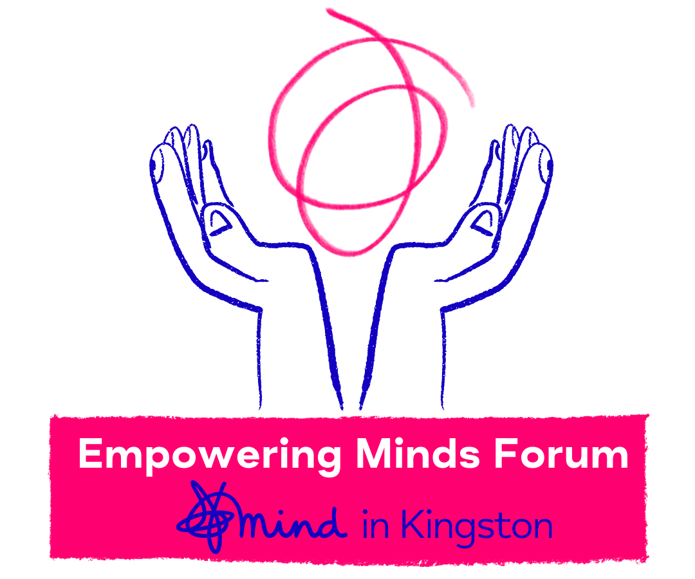
To apply:
Please download the volunteer application form from our website.
Please complete and send to persephone@mindinkingston.org.uk
If you require any support completing the application or have any questions, please email us, we would be happy to help.
We encourage and welcome applications from people with lived experience of mental health issues and/or those from racialised or marginalised communities.
You will be required to undergo an enhanced DBS check.

If you have any questions or accessibility needs, please feel free to contact Persephone at: persephone@mindinkingston.org.uk
We look forward to hearing from you!

Mind in Kingston
Siddeley House
50 Canbury Park Road
Kingston upon Thames
KT2 6LX
T: 020 8255 3939
E: info@mindinkingston.org.uk
Web: www.mindinkingston.org.uk
Registered charity number: 1076791

